|  |  |  |  |
| --- | --- | --- | --- |
| **Course Code:** | **ECE1002** | **Course Name:** | **Semiconductor Devices and Circuits Lab** |
| **Faculty In – Charge:** | **Dr. Pradeep Naryanan S.** | **Department:** | **SENSE** |
| **Name of the Student:** | **Aryan Pandey** | **Registration Number:** | **20BLC1087** |
| **Experiment No.:** | **1** | **Date of Experiment:** | **01.03.2021** |
| **Name of the Experiment:** | **DESIGN AND VERIFICATION OF PN JUNCTION DIODE** | | |

**OBJECTIVE: -**

To design and verify the function of the PN Junction diode using LTSPICE Simulator and observe its V-I characteristics.

**TOOLS: -**

LTSPICE XVII Simulator.

**THEORY**

**PN JUNCTION DIODE: -**

A PN Junction Diode is one of the simplest semiconductor devices around, and which has the characteristic of passing current in only one direction only. However, unlike a resistor, a diode does not behave linearly with respect to the applied voltage as the diode has an exponential current-voltage ( I-V ) relationship.

Zero bias: There is no external voltage applied to the p-n junction diode.

If a suitable positive voltage (forward bias) is applied between the two ends of the PN junction, it can supply free electrons and holes with the extra energy they require to cross the junction as the width of the depletion layer around the PN junction is decreased.

By applying a negative voltage (reverse bias) results in the free charges being pulled away from the junction resulting in the depletion layer width being increased.

Unbiased conditions in p n junction mean that there is no external energy source (no voltage) In an unbiased diode an electric field is set up across the depletion layer between the n-type and the p-type material.

In an unbiased p-n junction, holes diffuse from the p-region to the n-region because (1) Free electrons in the n-region attract them. (2) They move across the junction by the potential difference. (3) Hole concentration in p-region is more as compared to n-region.

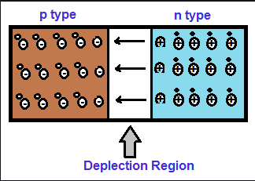

**FORWARD BIAS: -**

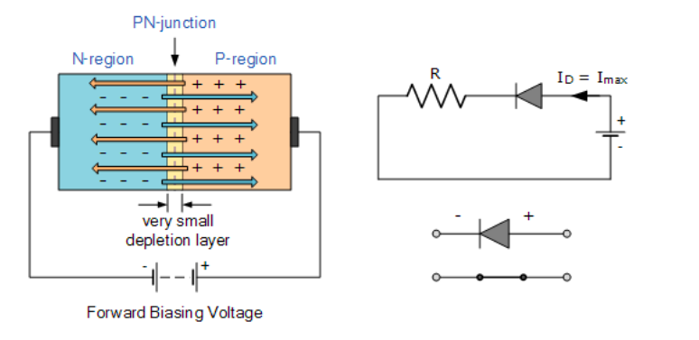

When a diode is connected in a Forward Bias condition, a negative voltage is applied to the N-type material and a positive voltage is applied to the P-type material. If this external voltage becomes greater than the value of the potential barrier, approx. 0.7 volts for silicon and 0.3 volts for germanium, the potential barriers opposition will be overcome and current will start to flow.

This is because the negative voltage pushes or repels electrons towards the junction giving them the energy to cross over and combine with the holes being pushed in the opposite direction towards the junction by the positive voltage. This results in a characteristics curve of zero current flowing up to this voltage point, called the “knee” on the static curves and then a high current flow through the diode with little increase in the external voltage as shown below.

This condition represents the low resistance path through the PN junction allowing very large currents to flow through the diode with only a small increase in bias voltage. The actual potential difference across the junction or diode is kept constant by the action of the depletion layer at approximately 0.3v for germanium and approximately 0.7v for silicon junction diodes.

Since the diode can conduct “infinite” current above this knee point as it effectively becomes a short circuit, therefore resistors are used in series with the diode to limit its current flow. Exceeding its maximum forward current specification causes the device to dissipate more power in the form of heat than it was designed for resulting in a very quick failure of the device.

**REVERSE BIAS: -**

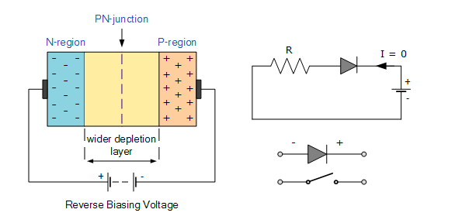

When a diode is connected in a Reverse Bias condition, a positive voltage is applied to the N-type material and a negative voltage is applied to the P-type material.

The positive voltage applied to the N-type material attracts electrons towards the positive electrode and away from the junction, while the holes in the P-type end are also attracted away from the junction towards the negative electrode.

The net result is that the depletion layer grows wider due to a lack of electrons and holes and presents a high impedance path, almost an insulator and a high potential barrier is created across the junction thus preventing current from flowing through the semiconductor material.

This condition represents a high resistance value to the PN junction and practically zero current flows through the junction diode with an increase in bias voltage. However, a very small reverse leakage current does flow through the junction which can normally be measured in micro-amperes, (μA).

One final point, if the reverse bias voltage Vr applied to the diode is increased to a sufficiently high enough value, it will cause the diode’s PN junction to overheat and fail due to the avalanche effect around the junction. This may cause the diode to become shorted and will result in the flow of maximum circuit current, and this shown as a step downward slope in the reverse static characteristics curve below.

**PROCEDURE**

**FORWARD BIAS: -**

* Open LT spice and select the new schematic button to draw a new circuit.
* Click on the component symbol and select voltage source place it in the required position. Add a resistor to the diagram by selecting it.
* Add a diode (Any) to your diagram in the same way. For this right click the diode. Click on diode name to pick it.
* The positive of the voltage source should be connected to positive of the diode for forward bias.
* Now we need to join the components together to build a circuit. Select the wire component from the top menu and join the components.
* Add a ground to your circuit.
* Next step is to specify values for your components. Right-click on the resistance and provide the required values. In our experiment let’s take it as 1k.
* Now pick the diode by right-clicking on the diode symbol. Select the option “**pick new diode**” and select the required diode from the pop-up list.
* Now finally we need to run our circuit to see the output. In order to do this, we need to click on the run button on the top menu. Select the “DC sweep” tab from the popup menu.
* Now provide the required values

1. Voltage source - V1
2. Type of sweep - linear
3. Start value - 0
4. Stop value - 1
5. Increment - 5mV

* Now you will have a screen with two windows. One is a graph and the other is a circuit.
* We need to plot the characteristics. To find the current, click on the diode symbol.

**REVERSE BIAS: -**

* Open LT spice and select the new schematic button to draw a new circuit.  
  Click on the component symbol and select a voltage source place it in the required position from the component option.
* Add a resistor to the diagram by selecting and dragging it to the required position from the components option.
* Add a diode (Any) to your diagram in the same way. For this right click the diode. Click on diode name to pick it.
* The positive of the voltage source should be connected to negative of the diode for reverse bias.
* Now we need to join the components together to build a circuit. Select the wire component from the top menu and join the components.
* Add a ground to your circuit.
* Next step is to specify values for your components. Right-click on the resistance and provide the required values. In our experiment let’s take it as 1k.
* Now pick the diode by right-clicking on the diode symbol. Select the option **“pick new diode”** and select the required diode from the pop-up list.
* Now finally we need to run our circuit to see the output. In order to do this, we need to click on the run button on the top menu. Select the “DC sweep” tab from the popup menu.
* Now provide the required values

1. Voltage source - V1
2. Type of sweep - linear
3. Start value - 0
4. Stop value - 1
5. Increment - 5mV

* Now you will have a screen with two windows. One is a graph and the other is a circuit.
* We need to plot the characteristics. To find the current, click on the diode symbol.

**VERIFICATION OF PN JUNCTION DIODE**

**FORWARD BIAS: -**

Forward biasing a PN junction diode is very simple. You just need to take a battery whose values can be varied from (o to V volts), connect its positive terminal to the p-side of PN junction diode and then connect the negative terminal of the battery to the n-side of the PN junction diode.

**USING THE 1N4148: -**

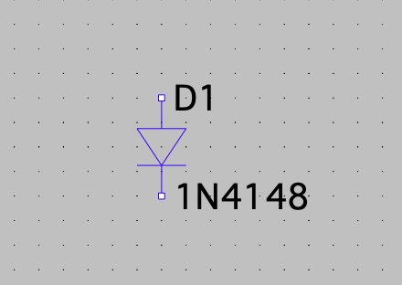

**Components Required: -**

Voltage source, Resistor, Wire, Ground and a specific Diode arranged in forward bias.

**Resistor Values Tested: -**

1. 5 OHMS
2. 10 OHMS
3. 100 OHMS
4. 1000 OHMS..(most appropriate)
5. 10000 OHMS

**Logic Diagram: -**

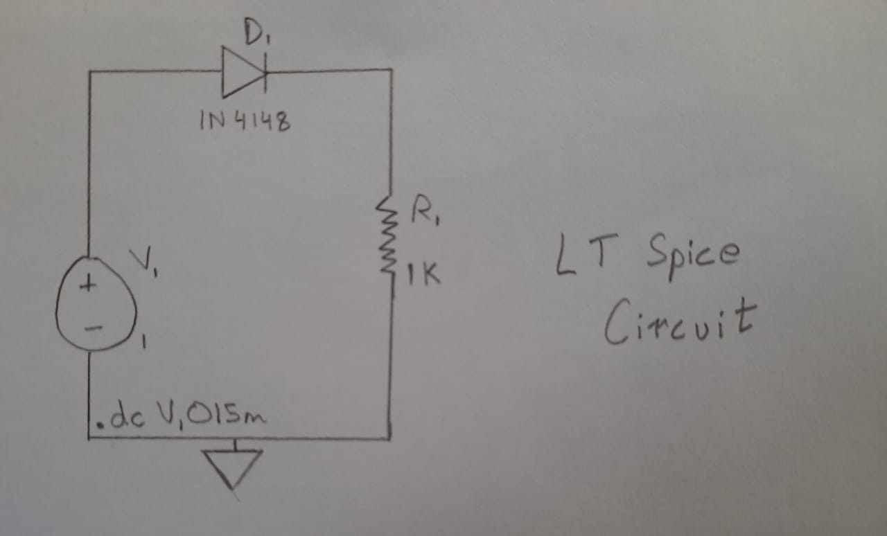

**Simulator Diagram: -**

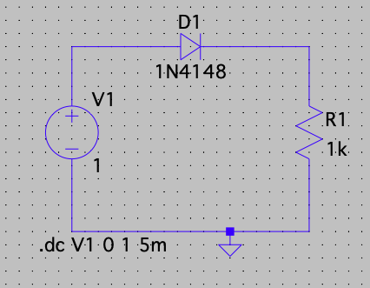

**Output Waveform: -**

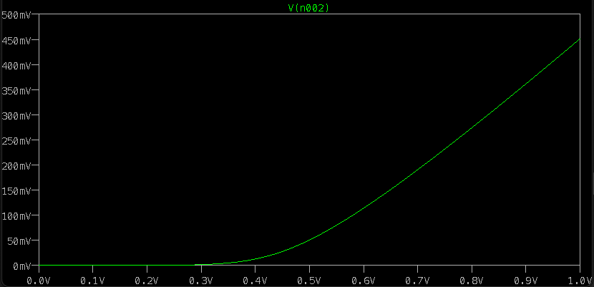

**REVERSE BIAS: -**

Reverse biasing a PN junction diode is very simple. You just need to take a battery whose values can be varied from (o to V volts), connect its positive terminal to the n-side of PN junction diode and then connect the negative terminal of the battery to the p-side of the PN junction diode.

**Using the 1N4148: -**



**Components Required: -**

Voltage source, resistor, wire, ground and a specific diode arranged in forward bias.

**Resistor Values Tested: -**

1. 5 OHMS
2. 10 OHMS
3. 100 OHMS
4. 1000 OHMS..(most appropriate)
5. 10000 OHMS

**Logic Diagram: -**

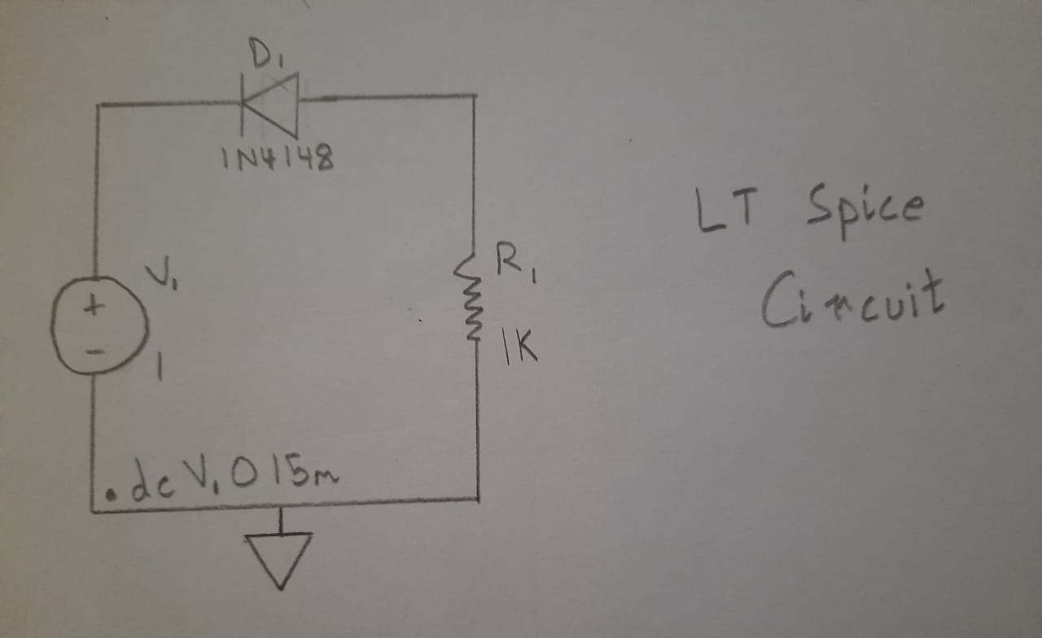

**Simulator Diagram: -**

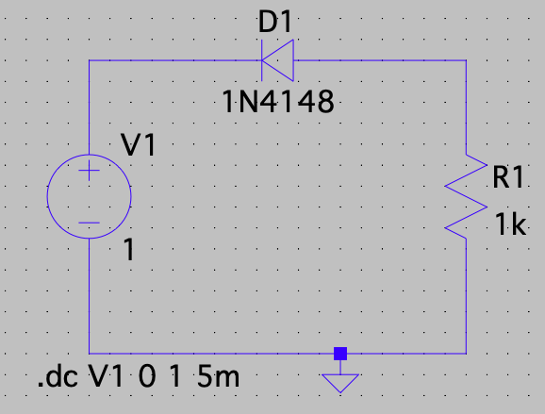

**Output Waveform: -**

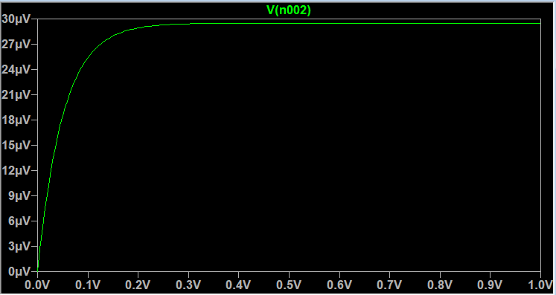

**INFERENCE**

**FORWARD BIAS: -**

* When forward biased as you can observe at zero voltage, zero current will flow through the diode. ​
* As voltage continues to raise there is no real raise in the current flow. ​
* But once voltage applied reaches 0.7v mark (for silicon diodes) the current increases drastically reaching maximum value that diode will allow passing through it safely. ​
* This voltage is referred as forward voltage or VF of a diode. ​
* This forward voltage will be 0.3v for Germanium diodes. ​
* Also, this forward voltage can vary from one diode of one type or material to another. ​
* This characteristic of diode will result in voltage drop of input voltage equivalent to this forward voltage value. ​

**REVERSE BIAS: -**

* When a diode is reverse biased no current flows through it until reverse voltage stays zero. ​
* When reverse voltage increases a very small current known as reverse leakage current starts flowing through the diode. ​
* This is the reason Diode is claimed to be blocking the current totally in reverse bias condition.​
* After a certain point when you further increase the reverse voltage, current starts flowing rapidly through the diode. ​
* At this point diode will act like a short circuit allowing current to flow through it without any restriction. ​
* This voltage at which the current flows through diode without any restriction in reverse biased state is known as Reverse breakdown voltage. ​
* In most of the diodes exceeding reverse breakdown voltage will result in overheating and failure of a diode. ​
* Therefore, you should always design in such a way the reverse bias voltage will not exceed reverse breakdown voltage.​

**RESULT: -**

**The VI characteristics of p-n junction in forward and reverse bias using LT Spice has been successfully verified.**